

PRAGYAN HARDWARE HACKATHON

**SMART HELMET (HEALTHCARE)**

**Name** **College ID/Roll UG/PG** **Course/Branch Semester**

|  |  |  |  |  |
| --- | --- | --- | --- | --- |
| Name | Roll Number | UG/PG | Branch | Semester |
| Vipin Kumar Niranjan | 205118085 | PG | MCA | III |
| Vaibhav Vikas | 205118081 | PG | MCA | III |
| Kunal Bhavsar | 205118030 | PG | MCA | III |
| Mrinal Satyawanshi | 205119057 | PG | MCA | I |
| Sunil Solanki | 205119103 | PG | MCA | I |

1. **Project Abstract:**

Road accidents—the leading cause of death by injury and the tenth-leading cause of all deaths globally—now make up a surprisingly significant portion of the worldwide burden of ill-health.Since road traffic injuries affect mainly males (73 percent of deaths) and those between 15 and 44 years old, this burden is creating enormous economic hardship due to the loss of family breadwinners. The direct consequence to such accidents are fatality(death), injury, property damage etc. Accidents may occur due to bad road conditions like potholes, damaged road, diversions and due to bad weather conditions as well. Most of the time the accidents take place in the abandoned areas where there is lack of population. Such accidents happen, and due to lack of treatment in proper time fatality occurs.

***Keywords— accident, amount of force, emergency contact.***

**2. Proposed Design:**

1. **Objective:**

* To detect the accident.
* To provide in-time treatment to the injured person.
* The device can be connected with an app which will send the location of the injured person and an alert message to some specific contacts like his family and ambulance.

1. **Proposed Solution:**
   1. **FLOW CHART:**

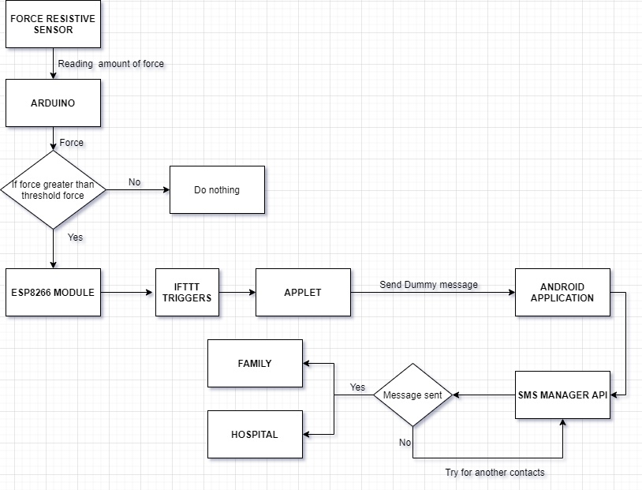

1. **Components Required:**

|  |  |
| --- | --- |
| COMPONENTS/PARTS | How is it being used in the proposed solution? Explain its role/functionality. |
| 1. HARDWARE |  |
| Wifi Module ESP8266 | The ESP8266 WiFi Module is a self contained SOC with integrated TCP/IP protocol stack that can give any microcontroller access to your WiFi network. |
| Arduino Uno | To connect the sensor and provide the desired result. |
| Force Sensitive Register | Thin sensor that detects physical pressure. |
| 1. SOFTWARE |  |
| Android application | For sending SMS and GPS location |
| Arduino IDE |  |
|  |  |
|  |  |

**3. Innovativeness of the Proposed Solution**

* It will check the amount of force with the Force Sensitive Register.
* Arduino checks whether given force is above threshold or not.
* It will be connected to a mobile device which connects it to internet.
* It will send the emergency message and GPS location to the members of the family of the person at the moment he meets with an accident.

**4.Impact of the proposed solution (Application):**

* It will reduce the death rate.
* It will increase the usage of helmet for safety.

**5.References**